**Problem Statement:**

You are working for the data analysis team and wish to analyse the data in hand for

Various demographic parameters. The analysis at hand involves basic data preparation,

processing and understanding. Further, you also wish to forecast the effects of certain

information on the overall Aadhaar number generation. The metadata/dictionary is

provided below:

Metadata/Data Dictionary

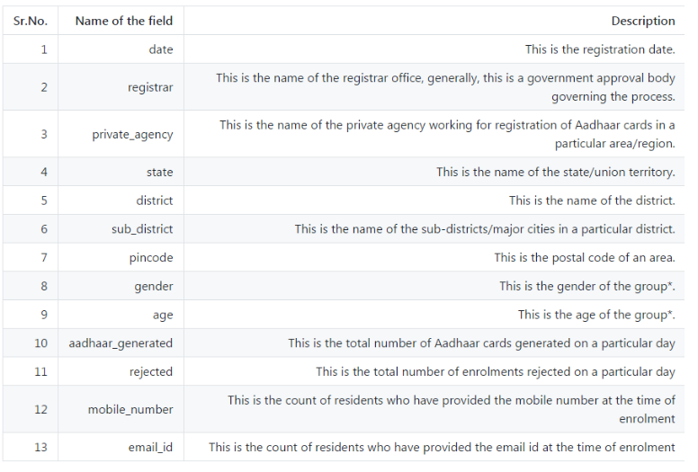

(*: explained in the example below).

Note: The dataset does not contain the headers. You should use the header names in

the order as mentioned above.

You can understand the data dictionary better by the following example: A row with data

- 20150420, Allahabad Bank, A-Onerealtors Pvt Ltd, Uttar Pradesh, Ambedkar Nagar,

Akbarpur, 224155, F, 15, 5, 0, 0, 4 indicates that

• On 20 Apr 2014 (date), for A-Onerealtors Pvt Ltd (private_agency) registered

with Allahabad Bank (registrar) at PIN code 224155, Akbarpur (sub_district),

Ambedkar Nagar (district), Uttar Pradesh (state)

• Among the group of women aged 15

• There were 5 Aadhar numbers generated and 0 were rejected

• Out of the 5 that applied, none had an email ID and 4 had mobile numbers